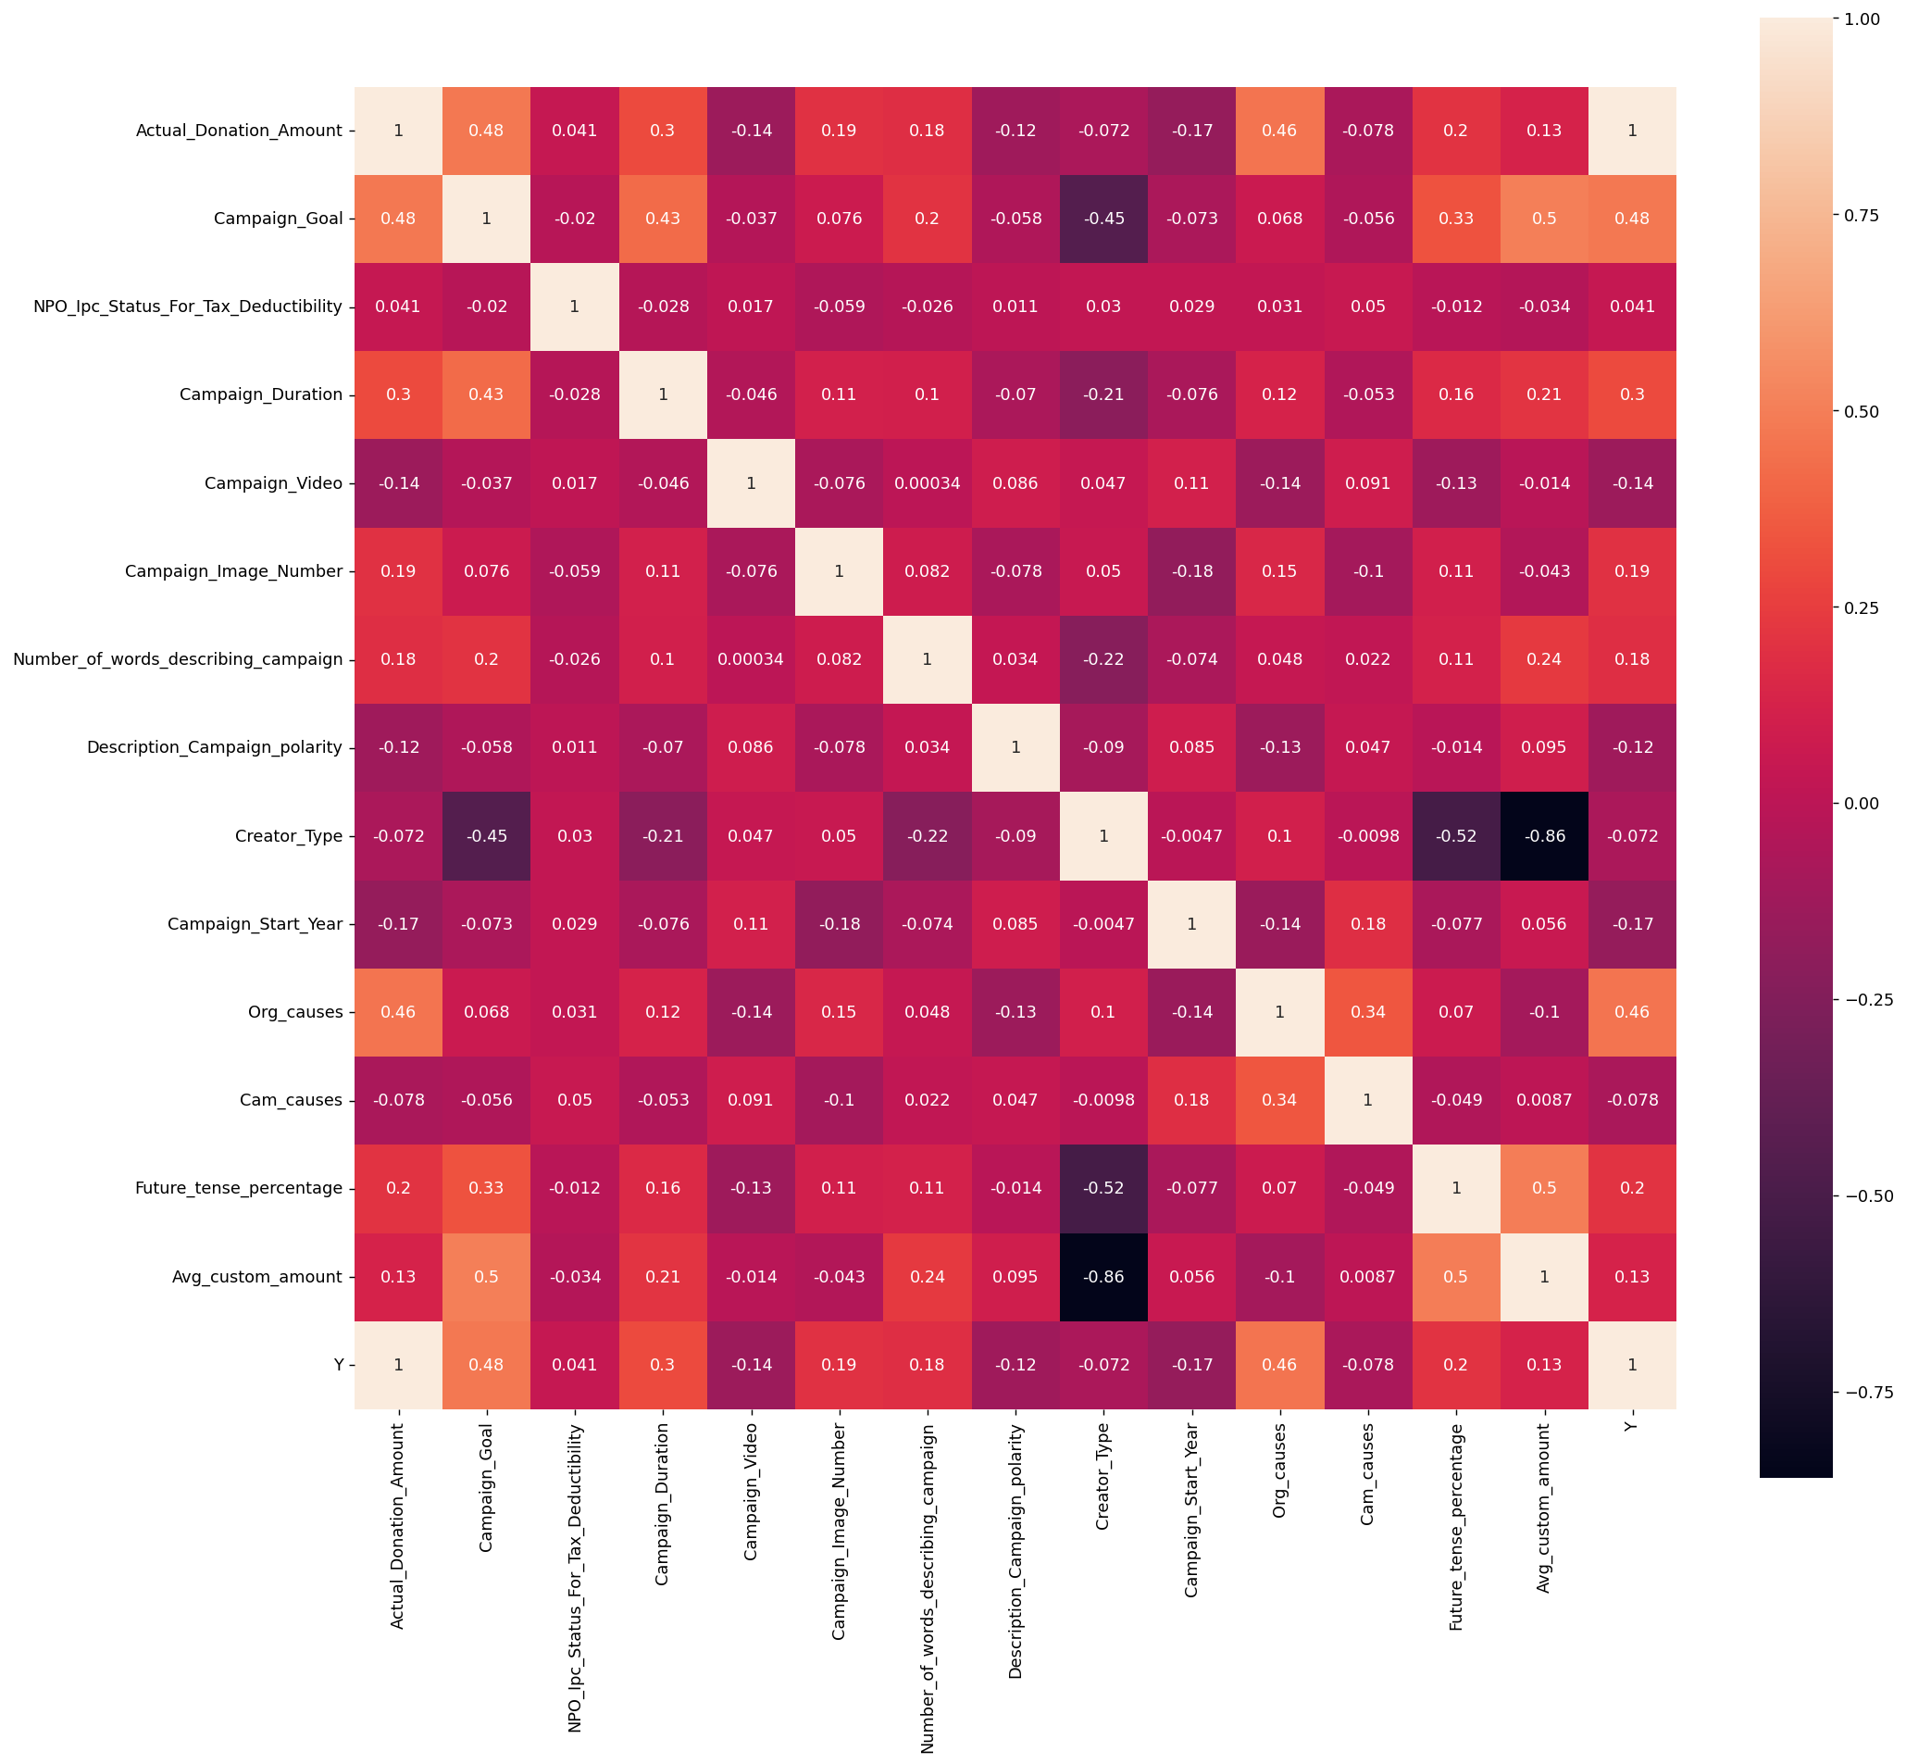

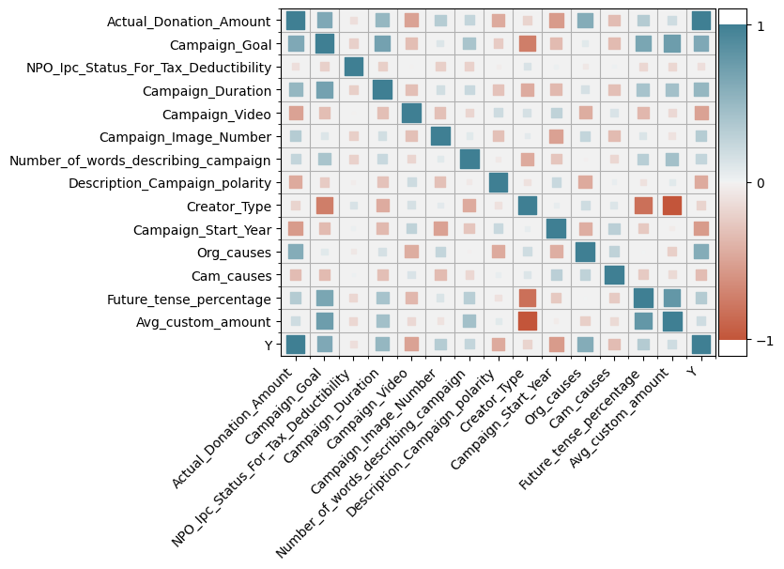

New Model

Table1 correlation Matrix and descriptive statistics

|  |  |  |  |  |  |  |  |  |  |  |  |  |  |  |  |  |  |  |  |  |
| --- | --- | --- | --- | --- | --- | --- | --- | --- | --- | --- | --- | --- | --- | --- | --- | --- | --- | --- | --- | --- |
|  |  | Mean | Std.Dev | Min | Max | [1] | [2] | [3] | [4] | [5] | [6] | [7] | [8] | [9] | [10] | [11] | [12] | [13] | [14] | [15] |
| [1] | DV: Donation Amount | 9984 | 63523 | 0 | 3431670 | 1 |  |  |  |  |  |  |  |  |  |  |  |  |  |  |
| [2] | Campaign Goal | 45030 | 154459 | 100 | 5000000 | 0.48 | 1 |  |  |  |  |  |  |  |  |  |  |  |  |  |
| [3] | Tax Deductibility | 0.93 | 0.24 | 0 | 1 | 0.041 | -0.02 | 1 |  |  |  |  |  |  |  |  |  |  |  |  |
| [4] | Campaign Duration | 4.21 | 1.02 | 0.69 | 6.45 | 0.3 | 0.43 | -0.028 | 1 |  |  |  |  |  |  |  |  |  |  |  |
| [5] | Campaign Video | 0.404 | 0.49 | 0 | 1 | -0.14 | -0.037 | 0.017 | -0.046 | 1 |  |  |  |  |  |  |  |  |  |  |
| [6] | Number of images | 2.87 | 1.59 | 0 | 5 | 0.19 | 0.076 | -0.059 | 0.11 | -0.076 | 1 |  |  |  |  |  |  |  |  |  |
| [7] | Words of campaign | 138 | 67 | 1 | 309 | 0.18 | 0.2 | -0.026 | 0.1 | 0.0003 | 0.082 | 1 |  |  |  |  |  |  |  |  |
| [8] | Campaign Polarity | 0.166 | 0.155 | -0.78 | 1 | -0.12 | -0.058 | 0.011 | -0.07 | 0.086 | -0.078 | 0.034 | 1 |  |  |  |  |  |  |  |
| [9] | Creator Type | 0.622 | 0.96 | 0 | 7 | -0.072 | -0.45 | 0.03 | -0.21 | 0.047 | 0.05 | -0.22 | -0.09 | 1 |  |  |  |  |  |  |
| [10] | Start_Year | 2020 | 1.4 | 2017 | 2022 | -0.17 | -0.073 | 0.029 | -0.076 | 0.11 | -0.18 | -0.074 | 0.085 | -0.005 | 1 |  |  |  |  |  |
| [11] | Organization Causes | 2.99 | 1.53 | 0 | 4 | 0.46 | 0.068 | 0.031 | 0.12 | -0.14 | 0.15 | 0.048 | -0.13 | 0.1 | -0.14 | 1 |  |  |  |  |
| [12] | Campaign Causes | 3.5 | 0.92 | 1 | 4 | -0.078 | -0.056 | 0.05 | -0.053 | 0.091 | -0.1 | 0.022 | 0.047 | -0.01 | 0.18 | 0.34 | 1 |  |  |  |
| [13] | Future tense percentage | 0.0109 | 0.021 | 0 | 0.129 | 0.2 | 0.33 | -0.012 | 0.16 | -0.13 | 0.11 | 0.11 | -0.014 | -0.52 | -0.077 | 0.07 | -0.049 | 1 |  |  |
| [14] | Avg custom amount | 243 | 7312 | 0 | 900000 | 0.13 | 0.5 | -0.034 | 0.21 | -0.014 | 0.043 | 0.24 | 0.095 | -0.86 | 0.56 | -0.1 | 0.0087 | 0.5 | 1 |  |

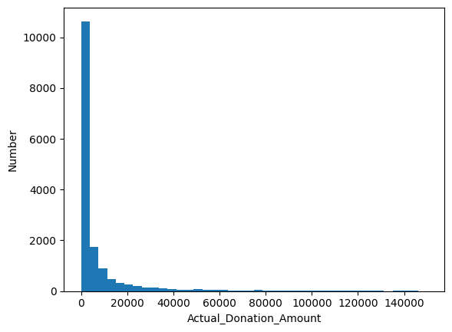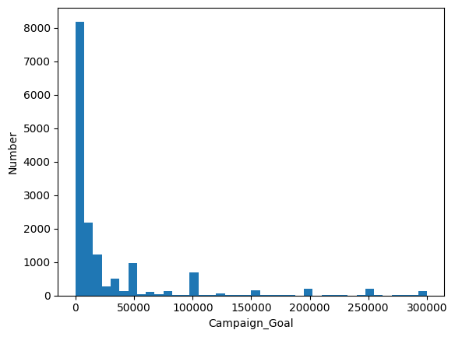

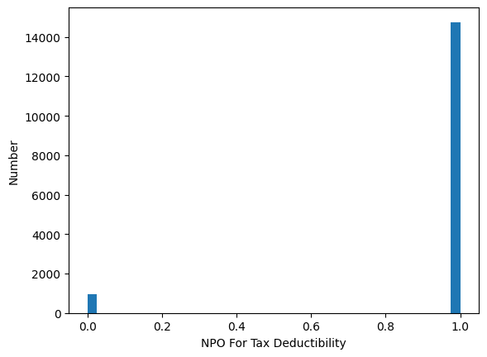 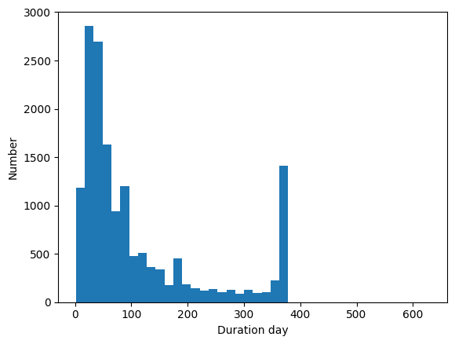 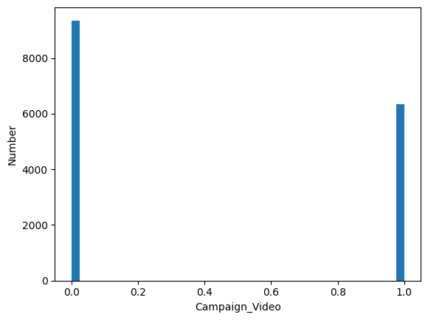 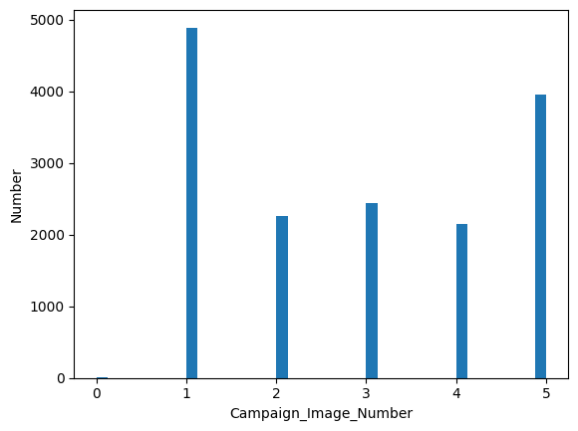

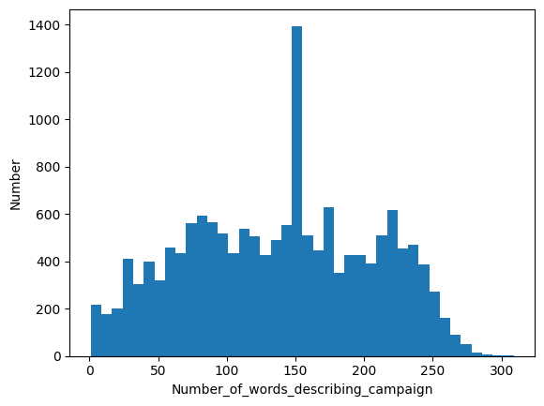 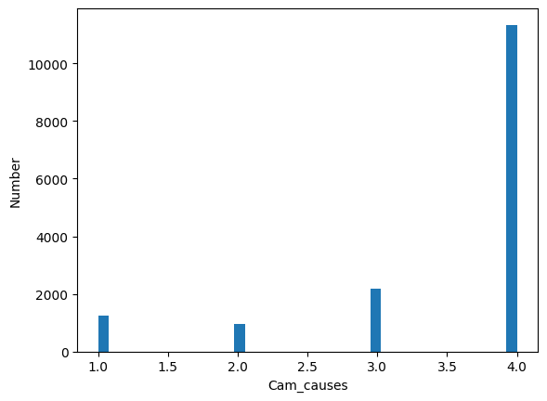

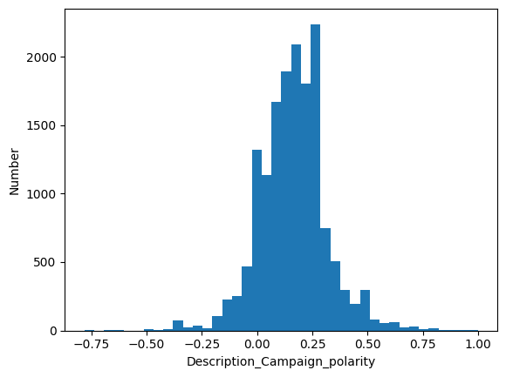 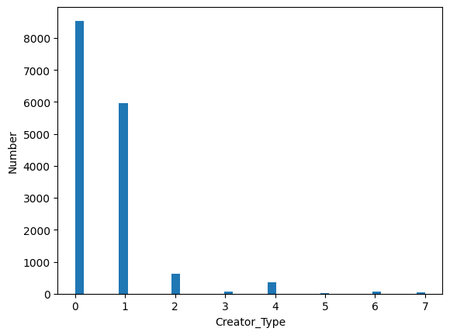

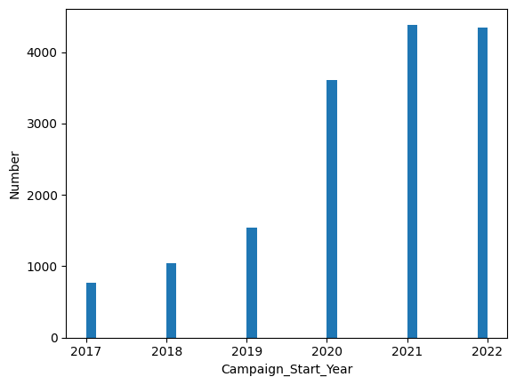 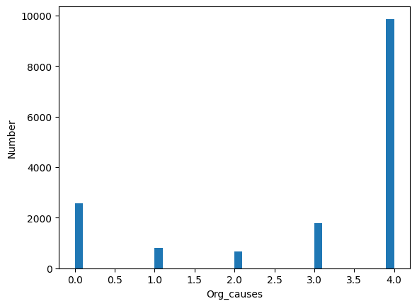

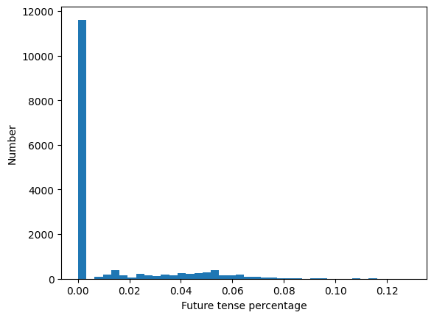 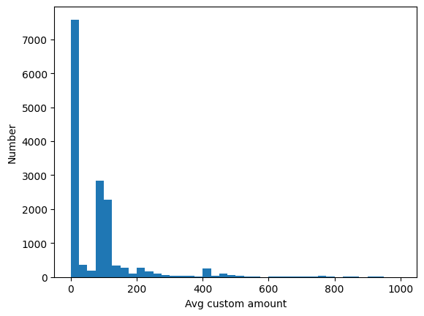

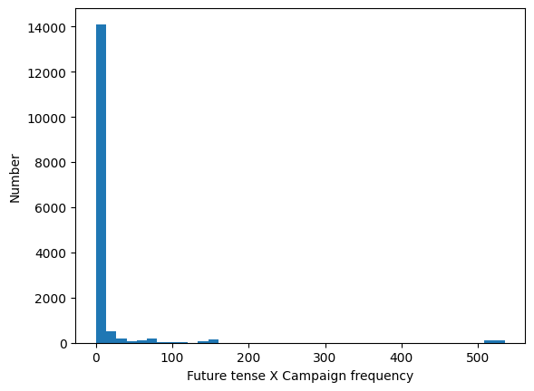

Log transformation

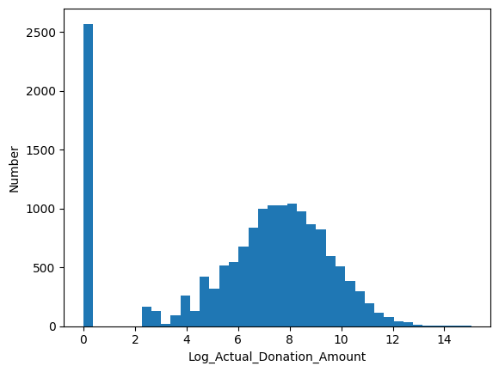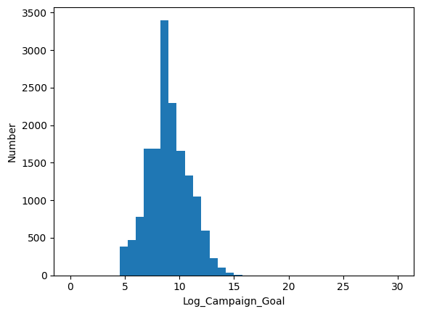

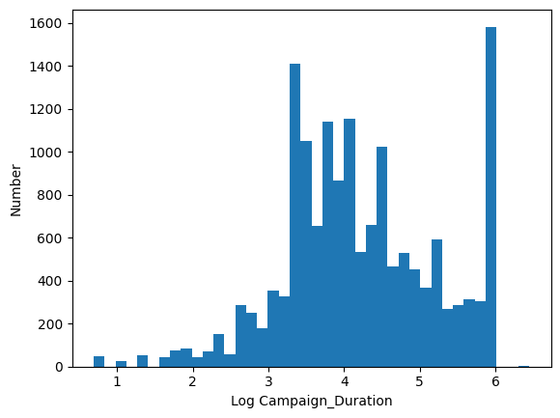 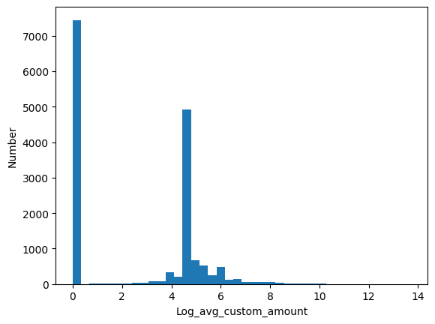

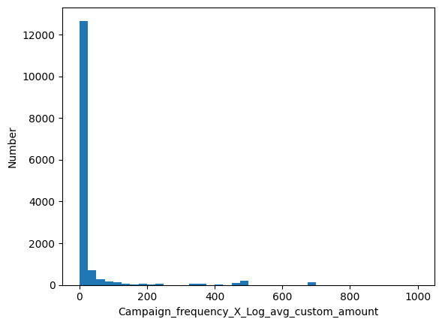

**VIF Test**

The new regression result.

With log transformation

Log campaign Goal 1.6590887138763837

NPO Ipc Status For Tax Deductibility 1.0222740248215232

Log campaign Duration 1.256935570109766

Campaign Video 1.1423457558384136

Campaign Image Number 1.1492627955980104

Number of words describing campaign 1.11163856548817

Description_Campaign_polarity 1.0513827517447998

Creator Type* 1.7897763485305238

Campaign_Start_Year 1.1741539350664034

Org_causes 1.5404374982322386

Cam_causes 1.2478952354912343

Future tense 1.5690459684345224

Log avg custom amount 2.829957703897947

Future tense X Campaign frequency 1.252933221540558

Campaign frequency X Log avg custom amount 1.9061019554501992

Without log transformation

Campaign_Goal 1.0742085250239686

NPO_Ipc_Status_For_Tax_Deductibility 1.0135782867855405

Campaign_Duration 1.094456066114764

Campaign_Video 1.0616484283746785

Campaign_Image_Number 1.093218608183399

Number_of_words_describing_campaign 1.0345705611722487

Description_Campaign_polarity 1.0241247058131868

Creator_Type 1.1872538399750519

Campaign_Start_Year 1.13160906658436

Org_causes 1.232413811109643

Cam_causes 1.1995125335277952

Future_tense 1.1781728637442845

Avg_custom_amount 1.0167756822177014

**Normality test without BOX-COX transformation**

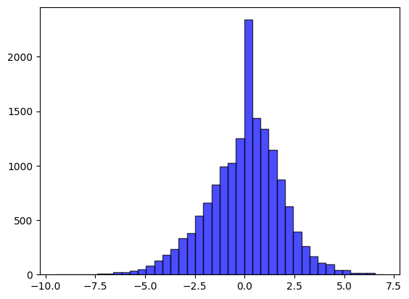

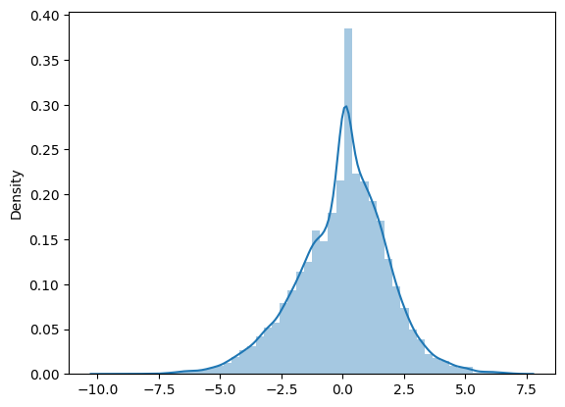

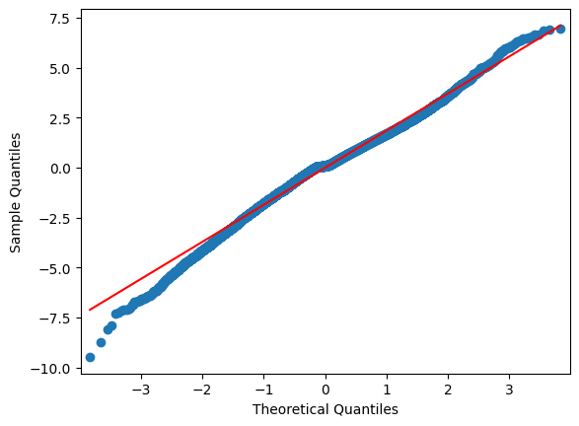

Result based on original data set:

Model 1

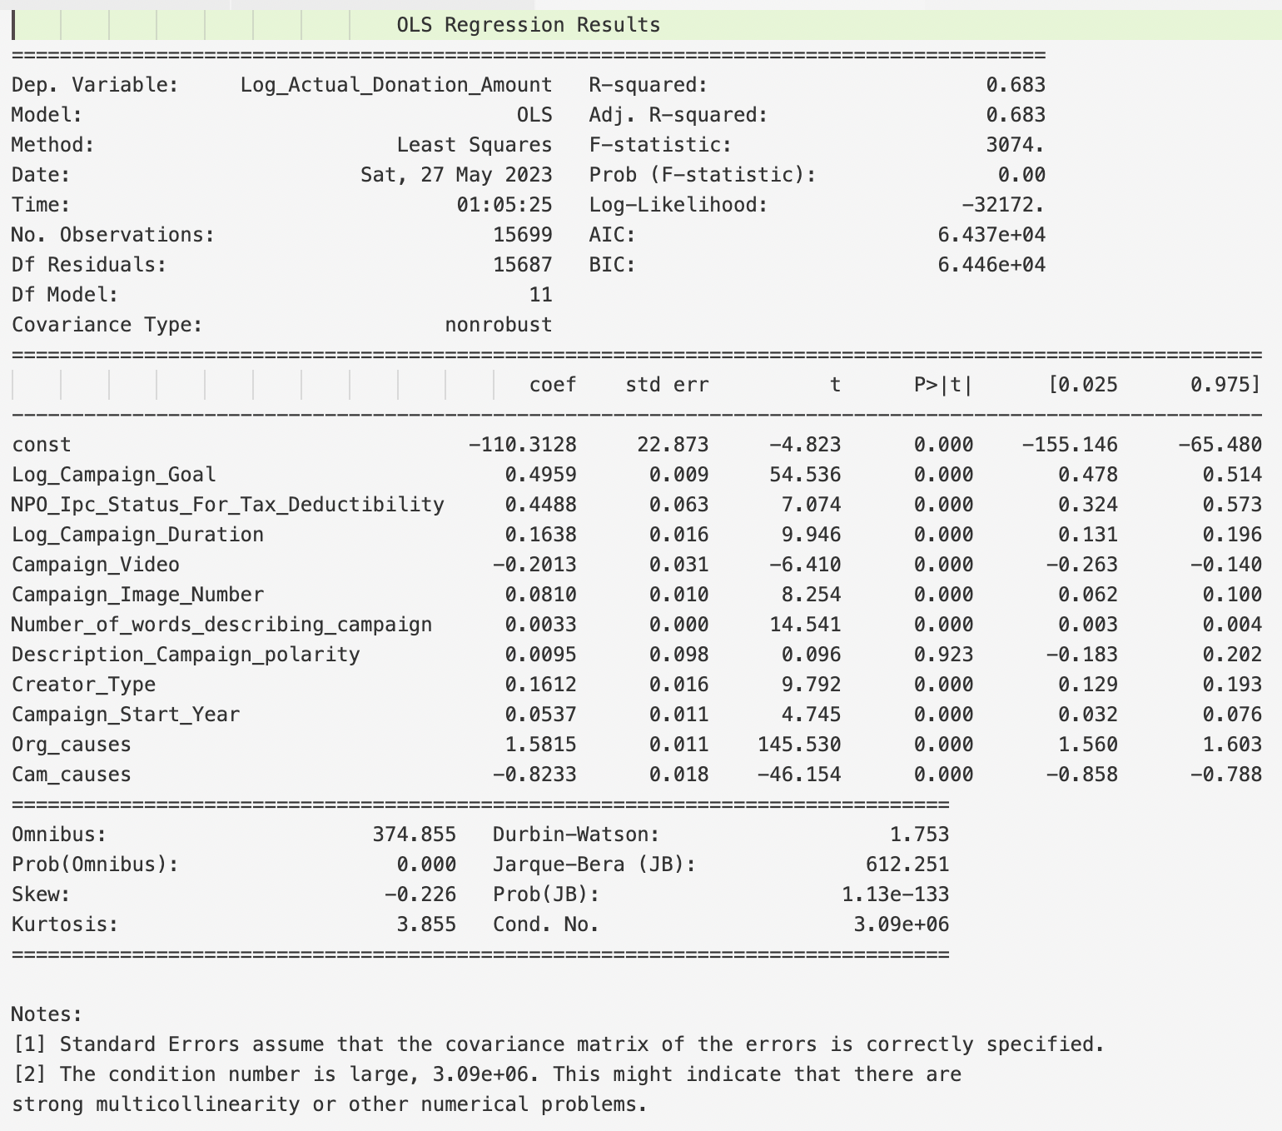

Model 2

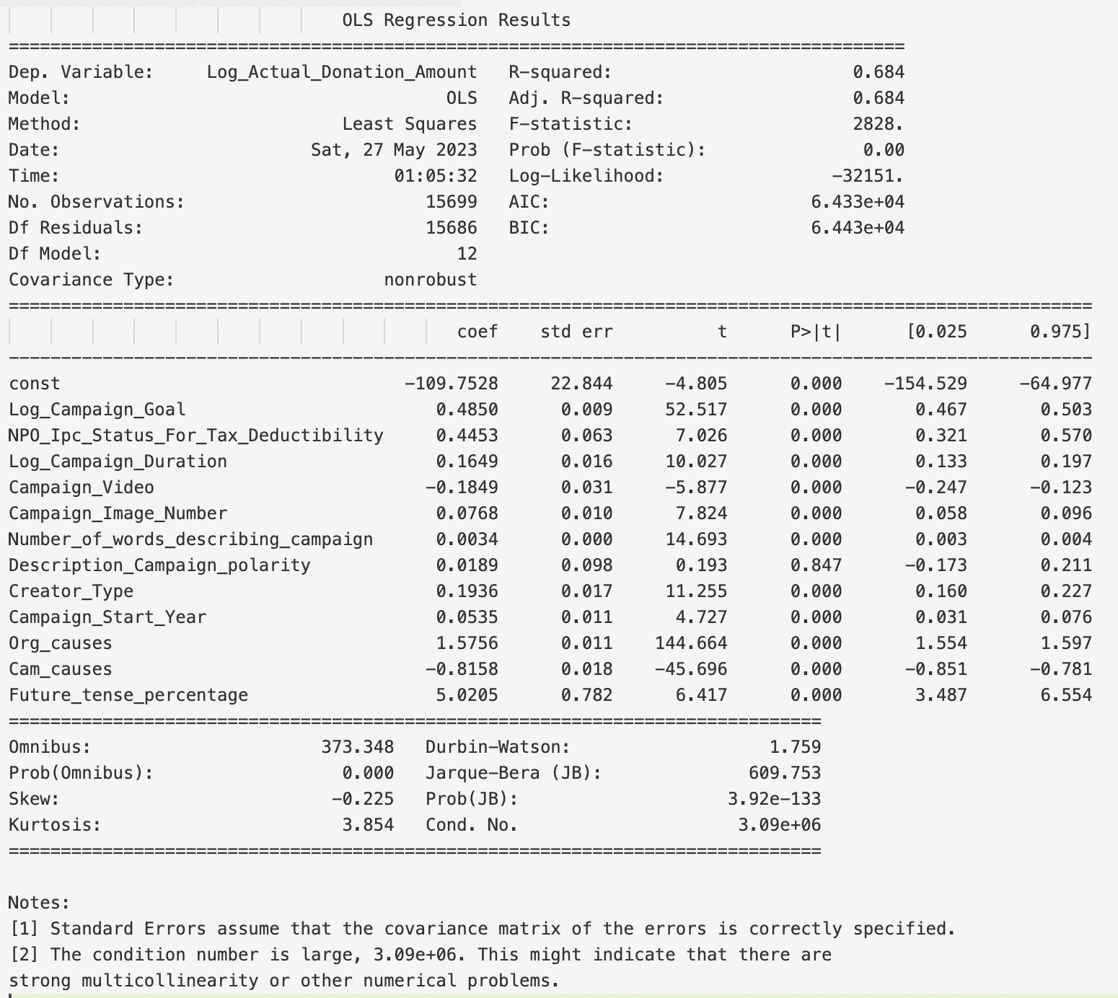

Model 3

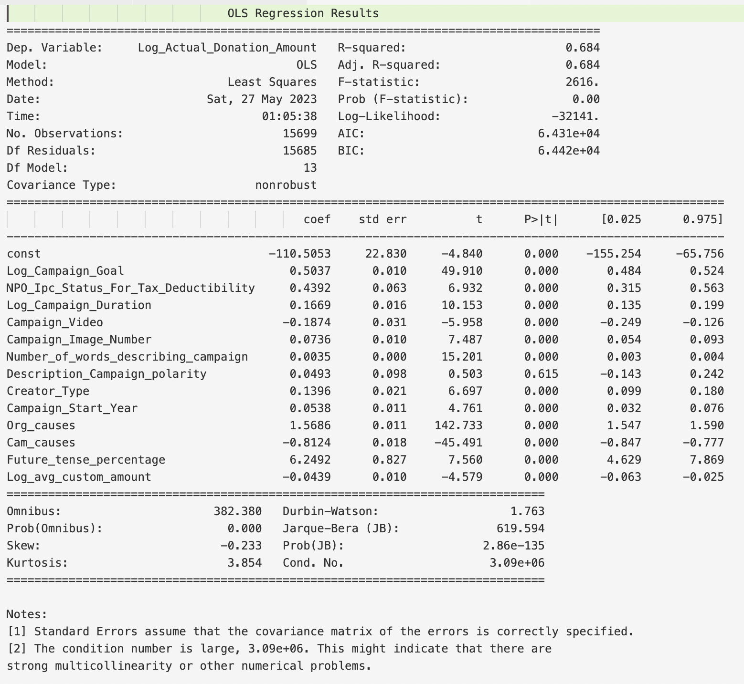

Model 4

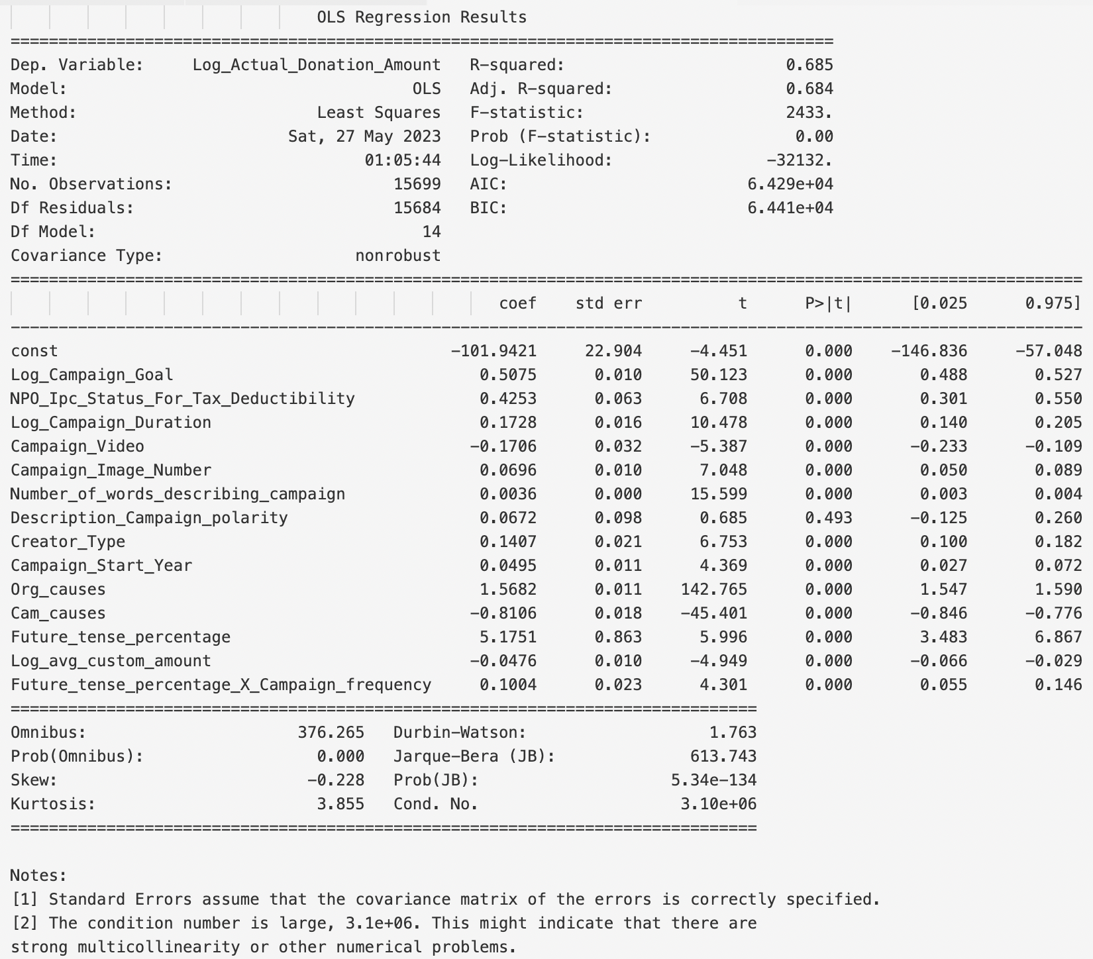

Model 5-1

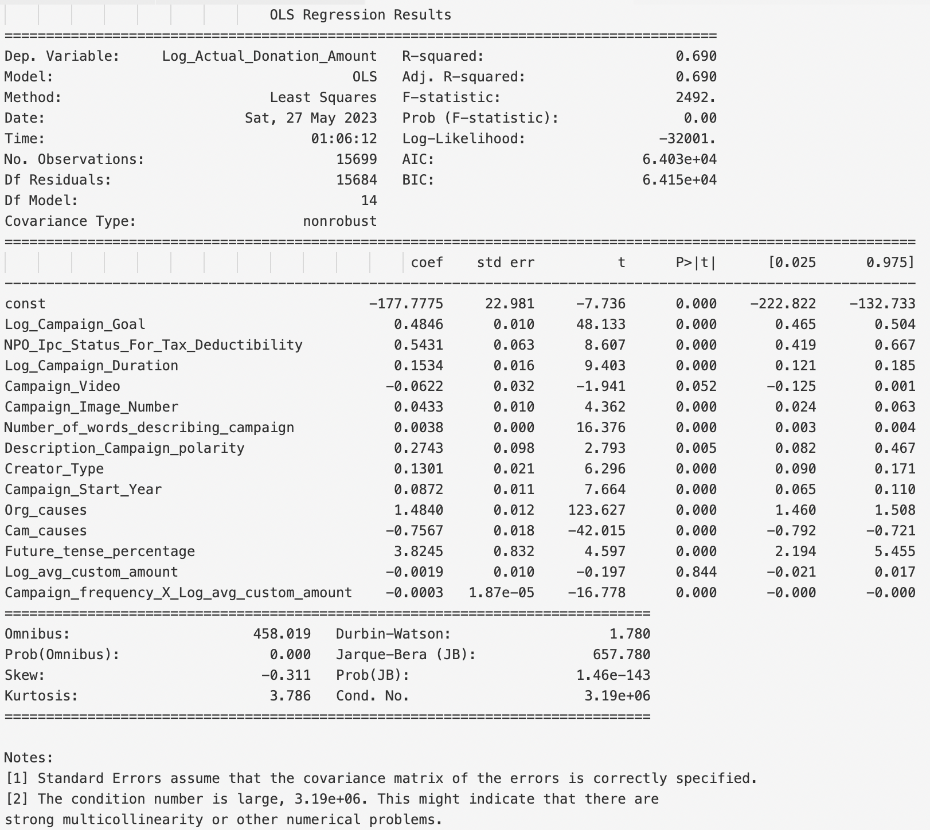

Model 5-2

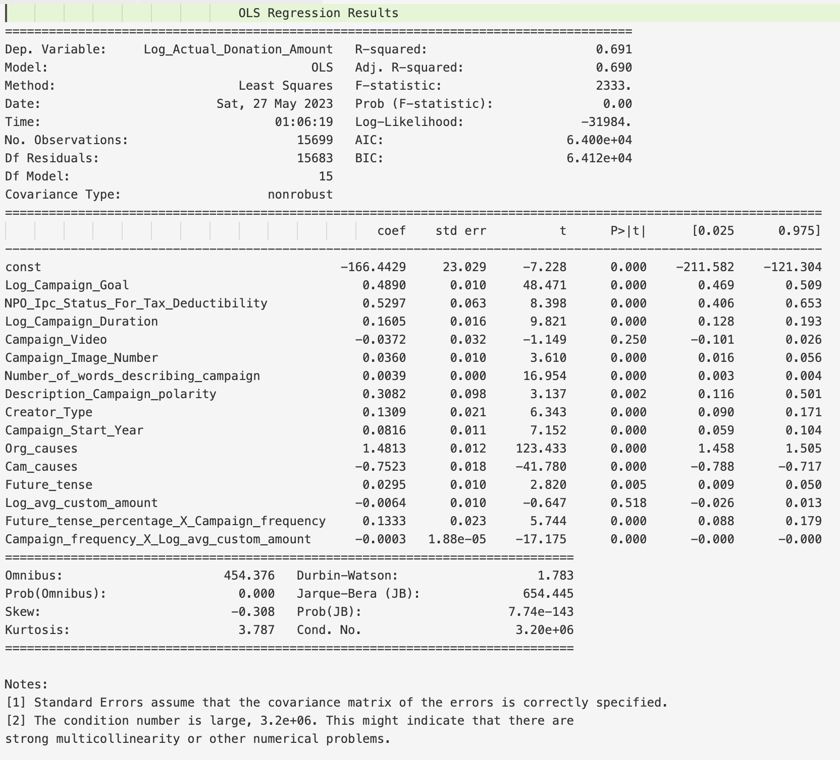

Robust test Model 6

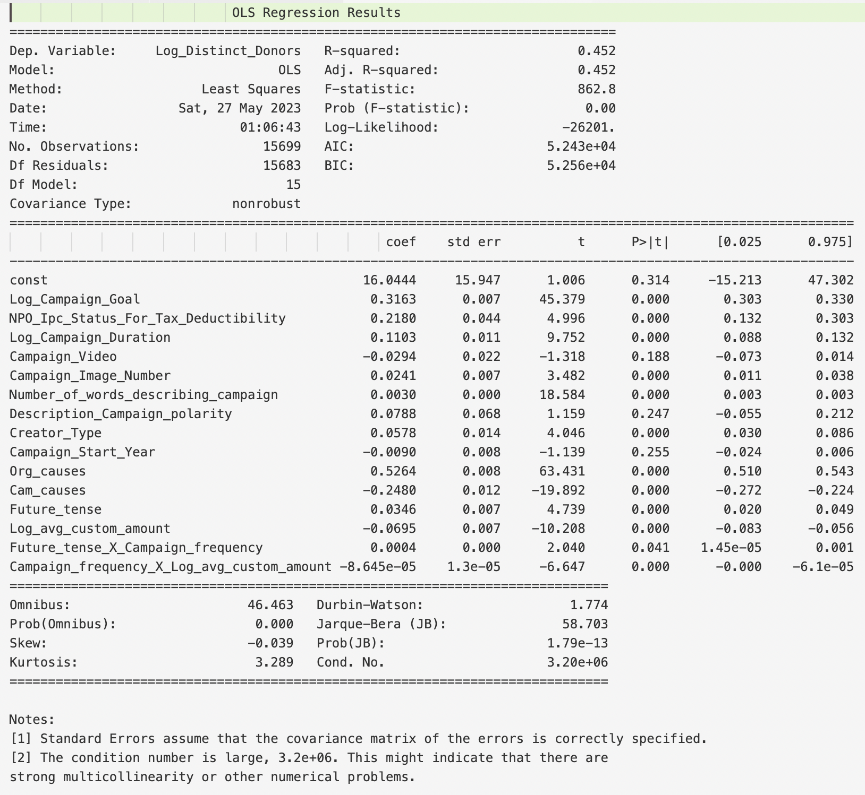

plot:

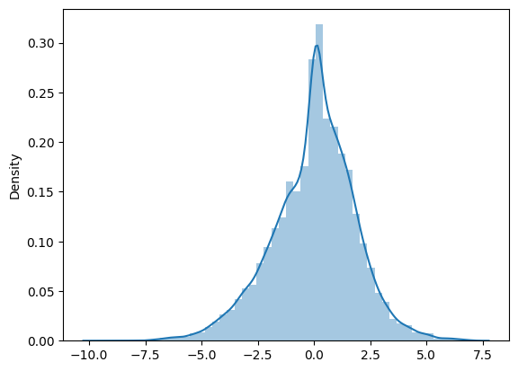

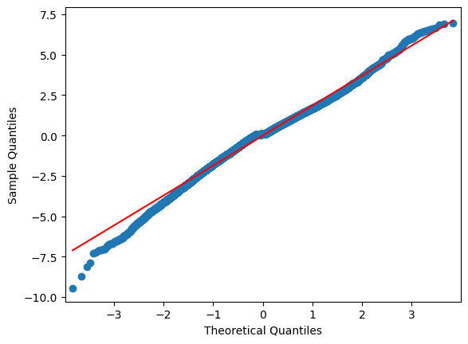

Scatter plot:

